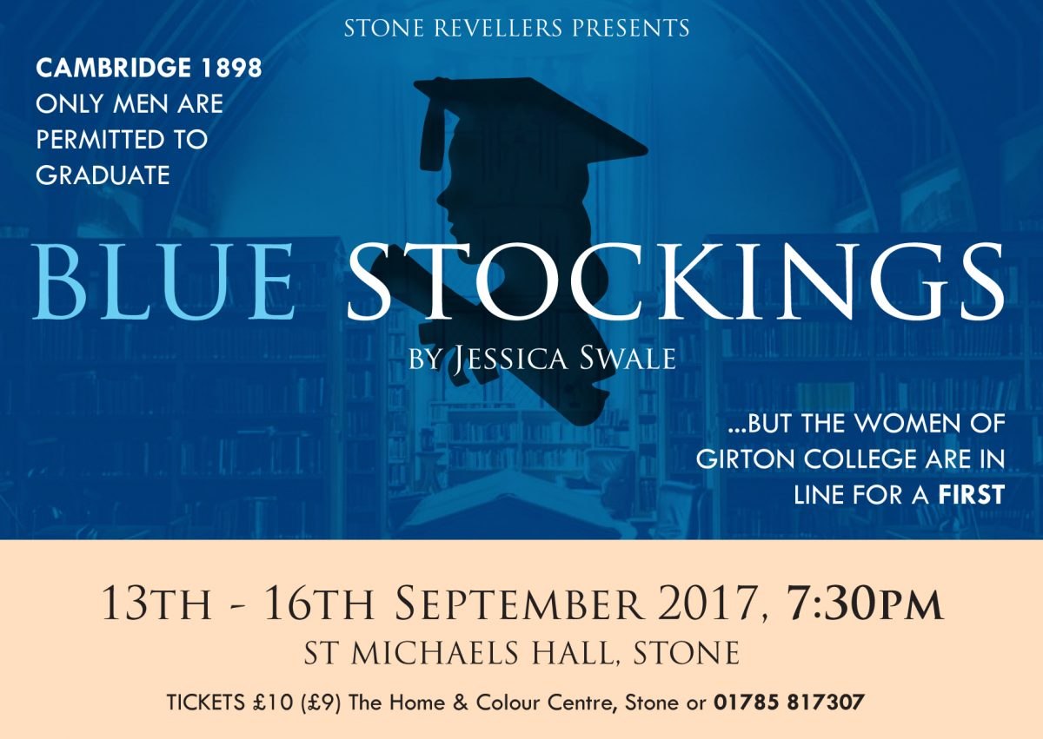

Cast List
The Boys
Will Bennett: Haiden Lee
Ralph Mayhew: Mason Alig
Lloyd: Trenton Rogers
Edwards: Hunter Martin
Holmes: Beau Slayton
The Male Staff/Other Men
Mr. Thomas Banks: Joseph Buczko
Dr. Maudsley/Billy Sullivan/Anderson/Husband:
Aaron Olson
Radleigh/Peck: Isaac Keck
Collins/Waiter: Tyler Gallion

The Girls
Tess Moffat: Addy Allard
Celia Willbond: Hannah Steck
Carolyn Addison: Bella Jarvis
Maeve Sullivan: Alanah Howarter
The Female Staff
Mrs. Elizabeth Welsh: Kaitlynn Tutt
Miss Elenaor Blake: Ciara Wallace
Miss Bott: Haleigh Bohn
The Other Women
Minnie: Kelsey Watson
Librarian/Mrs. Lindley/Lady in Café: Medina Bilalli

CONGRATULATIONS!
Our first read through will be held on Sunday, September 8 from 2:00 p.m.-5:00 p.m. (approximate end time) in the CHS auditorium. Please bring a pencil and highlighter with you. (Isaac and Tyler, please also bring a binder). We can’t wait to get started!

